**OFFER LETTER**

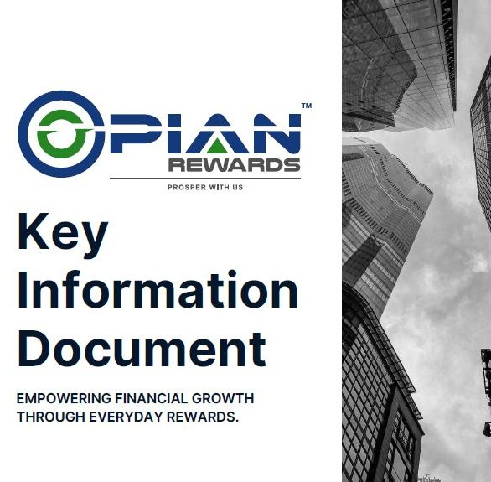

**PRIVATE EQUITY PROPOSAL**



**Private Equity Proposal – CAPITAL GROWTH**

Turning R150,000 into R258,000 (72% Growth) in 3 Years Prepared for:

Address:

Date:

**Dear**

**We thank you for your interest in our Private Equity Proposal**

1. **Executive Summary**

This proposal outlines a strategic private equity (PE) investment strategy designed to grow an initial capital of R150,000 by 72% (R258,000 total) over a 3-year horizon. By leveraging high- growth private equity opportunities in carefully selected industries, we aim to maximize returns while mitigating risks through diversification and expert fund management.

# Key Highlights:

* + Target Return: 72% growth (R108,000 profit) in 3 years (~24% annualized return).
  + Investment Strategy: Focus on growth equity in high-potential sectors.
  + Risk Management: Portfolio diversification, and active management.
  + Exit Strategy: Share buybacks, IPOs, or secondary buyouts after 3 years.

# Investment Opportunity & Market Outlook

Private equity has historically outperformed public markets, delivering **12-25%+** annual returns in emerging markets like South Africa and BRICS. Key sectors with strong growth potential include:

Technology & FinTech (Digital payments, SaaS, AI Related business)

Consumer Goods & Retail (E-commerce, premium brands, Rewards, Lifestyle products) Healthcare & Pharma (Telemedicine, generics manufacturing)

Renewable Energy (Solar, battery storage)

By investing in early stage but undervalued businesses with strong cash flow, IP and scalability, we position the portfolio for accelerated growth.

# Proposed Investment Structure

|  |  |
| --- | --- |
| **Component** | **Details** |
| Investment Amount | R150 000, 00 |
| Target Return | R258 000, 00 (72% growth) |
| Time Horizon | 3 years |
| Annualised Return | ~24% |
| Investment Vehicle | Private Equity / Direct Investment |
| Key Sectors | FinTech, Lifestyle, Online Education |

**Why Private Equity?**

 Higher Returns: PE typically outperforms stocks & bonds.

 Active Value Creation: Hands-on management improves business performance.

 Lower Volatility: Unlike public markets, PE is less exposed to short-term fluctuations.

# Projected Returns & Cash Flow

|  |  |  |  |  |  |
| --- | --- | --- | --- | --- | --- |
| **Year** | **Shares Issued** | **Div Allocation** | **Div Return** | **Growth (%)** | **Investment Value** |
| Year 0 | - | - | - | - | R150 000, 00 |
| Year 1 | 18,750 | 1.440 | R27 000, 00 | 18.00% | R177 000, 00 |
| Year 2 | 18,750 | 1.888 | R35 400, 00 | 23.60% | R212 400, 00 |
| Year 3 | 18,750 | 2.378 | R45 600, 00 | 29.73% | R258 000, 00 |

* Note: While returns are based on historical PE performance; actual results may vary.
* Fund Value is non liquid
* The investment is locked into the period with no access to investment

# Risk Mitigation Strategy

To safeguard capital while pursuing high returns, we implement:

⬛ Diversification across 1-5 high-growth potential companies

⬛ Due Diligence on management teams, financials, and market trends

⬛ Structured Exit Plans (Share swops, IPO, recapitalization, buyouts)

⬛ Co-Investment Model (Reduces exposure via partnerships)



# Why Invest With Us?

✔ Industry Expertise: Deep knowledge of South African & African markets

✔ Transparent Fees: Performance-based compensation (2% management fee + 20% carry)

✔ Aligned Interests: We invest alongside clients

✔ Ownership: We take ownership and management stake in companies we invest in

# Next Steps

1. **Decision Taking:** Deciding on risk appetite & capital to be invested
2. **FAIS Process:** Making investment and completing documentation
3. **Capital Deployment:** We begin investment within 2-6 weeks post due diligence.
4. **Quarterly Reporting:** Transparent updates on performance.



# Conclusion

This private equity strategy offers a compelling opportunity for superior growth on your investment by leveraging equity in high-growth, privately held businesses. With disciplined risk management and sector expertise, we are confident in delivering superior returns.

Thank you for your consideration. Please reach out to me if there are further concerns or let’s

discuss how we can tailor this strategy to your goals. Kind Regards

*\*Disclaimer: This proposal is for illustrative purposes only. Past performance is not indicative of future results. Private equity involves risk, including potential loss of capital. Investors should conduct independent due diligence before committing funds.*

*\*This proposal, hen signed and accepted, ill become part of the Agreement ith the client CLIENT CONFIRMATION*

I, The undersigned, hereby accept the proposal as outlined in the documentation contained herein. I confirmed that I had made an informed decision based on my own financial product experience and/or external consultation with professionals. I confirm that I have the financial capacity to enter into this agreement and also the additional financial resources which allow me the opportunity to enter the waiting periods/ lock up periods/ and or risk associated with this product

Signed at on 202

Signature of Client:

Name of Client:

Date Signed: